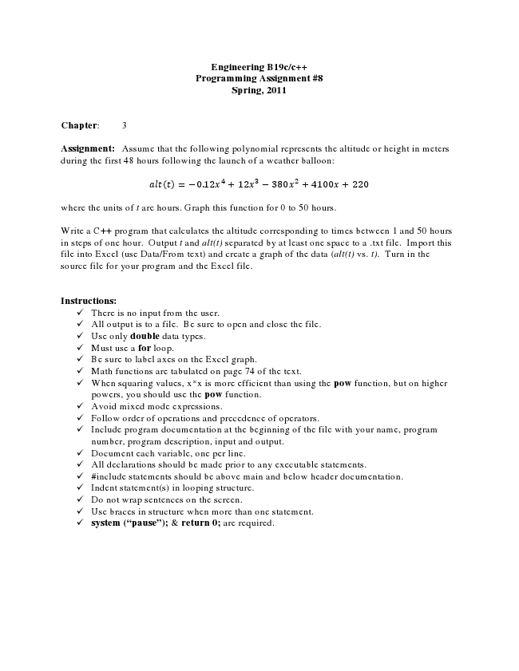

**Engineering B19c/c++ Programming Assignment #8 Spring, 2011**

**Chapter: 3**

Assignment: Assume that the following polynomial represents the altitude or height in meters during the first 48 hours following the launch of a weather balloon:

= −0.12 + 12 − 380 + 4100 + 220

where the units of t are hours. Graph this function for 0 to 50 hours.

Write a C++ program that calculates the altitude corresponding to times between 1 and 50 hours in steps of one hour. Output t and alt(t) separated by at least one space to a .txt file. Import this file into Excel (use Data/From text) and create a graph of the data (alt(t) vs. t). Turn in the source file for your program and the Excel file.

**Instructions:**

✓ There is no input from the user. ✓ All output is to a file. Be sure to open and close the file. ✓ Use only double data types. ✓ Must use a for loop. ✓ Be sure to label axes on the Excel graph. ✓ Math functions are tabulated on page 74 of the text. ✓ When squaring values, x*x is more efficient than using the pow function, but on higher

powers, you should use the pow function. ✓ Avoid mixed mode expressions. ✓ Follow order of operations and precedence of operators. ✓ Include program documentation at the beginning of the file with your name, program

number, program description, input and output. ✓ Document each variable, one per line. ✓ All declarations should be made prior to any executable statements. ✓ #include statements should be above main and below header documentation. ✓ Indent statement(s) in looping structure. ✓ Do not wrap sentences on the screen. ✓ Use braces in structure when more than one statement. ✓ system (“pause”); & return 0; are required.